**ANN Model Architecture**

**1-Architecture Overview:**

**a. Input Layer:** Matches the number of input features (based on preprocessed data).

**b. Hidden Layers:**

Layer 1: 256 neurons with ReLU activation, batch normalization, and a 0.5 dropout rate.

Layer 2: 128 neurons with ReLU activation, batch normalization, and a 0.4 dropout rate.

Layer 3: 64 neurons with ReLU activation, batch normalization, and a 0.3 dropout rate.

Layer 4: 32 neurons with ReLU activation and a 0.2 dropout rate.

Layer 5: 16 neurons with ReLU activation and a 0.2 dropout rate**.**

**c. Output Layer:**

1 neuron with a sigmoid activation function for binary classification (churn prediction).

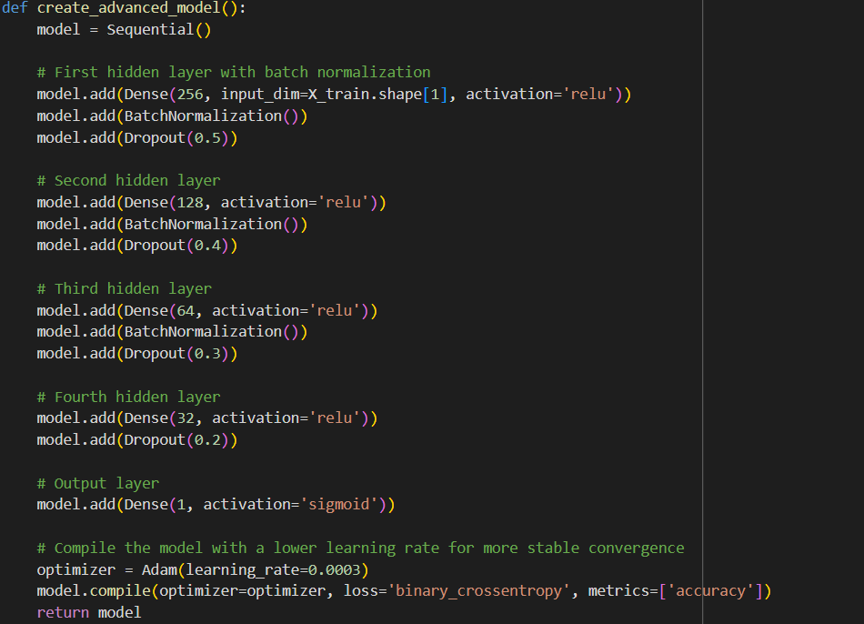

**2-Training Configuration:**

**a. Optimizer**: Adam optimizer with a learning rate of 0.0002.

**b. Loss Function**: Binary cross-entropy, suitable for binary classification.

**c. Metrics**: Accuracy to monitor training and validation performance.

**d. Callbacks**:

**1- ReduceLR OnPlateau**: Dynamically reduces the learning rate when validation loss plateaus.

**2- Early Stopping**: Stops training if validation loss doesn’t improve for 10 epochs.

**3-Regularization Techniques:**

Dropout rates applied after each hidden layer to reduce overfitting.

Batch normalization applied to stabilize activations and speed up convergence.